Assignment for Week 12 - Mongo DB Exercise -

@Mathankumar.N

# Question 1 :

**Create Operation:**

1. Create a new database named "library" and switch to it.
2. Create a collections named "books" with fields: title, author, and published_year.
3. Insert a document into the "books" collection with the details of your favorite book.

# Answer :

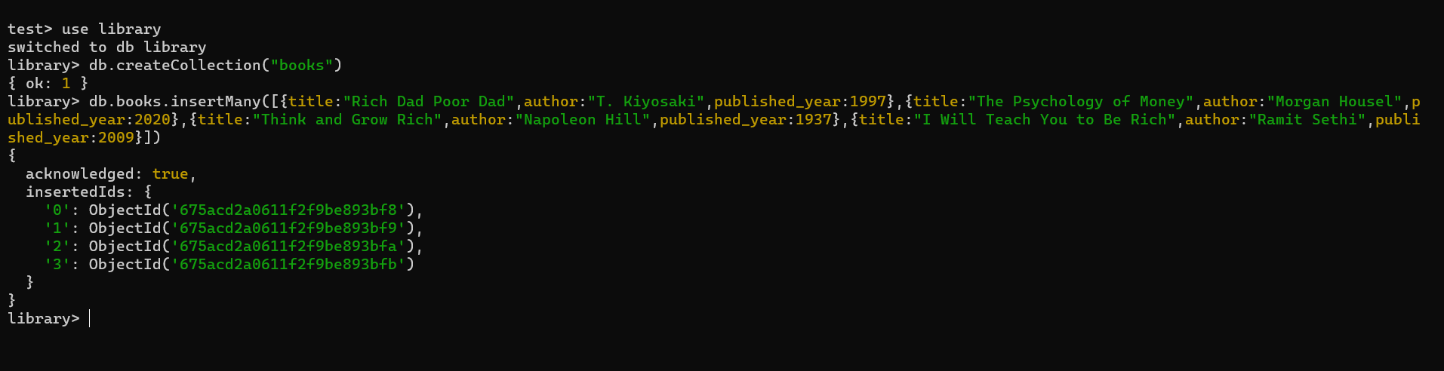

**Read Operation:**

1. Retrieve all documents from the "books" collection.
2. Find and display only the documents where the author is "Morgon Housel".
3. Fetch and display the document with the earliest published year.

# Answer :

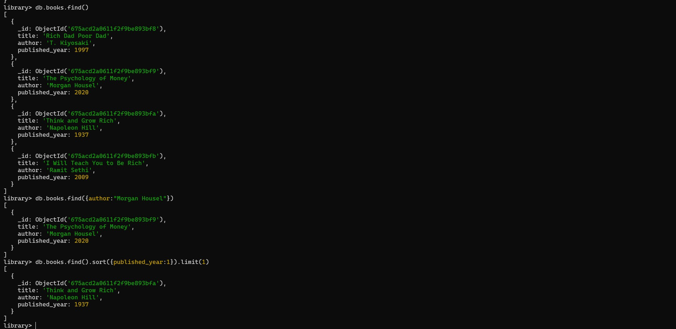

**Update Operation:**

1. Update the published year of the book with the title "The Intelligent Investor" , author “Benjamin graham” to the current year.
2. Add a new field "genre" with the value "Money" to all documents in the "books" collection.

# Answer :

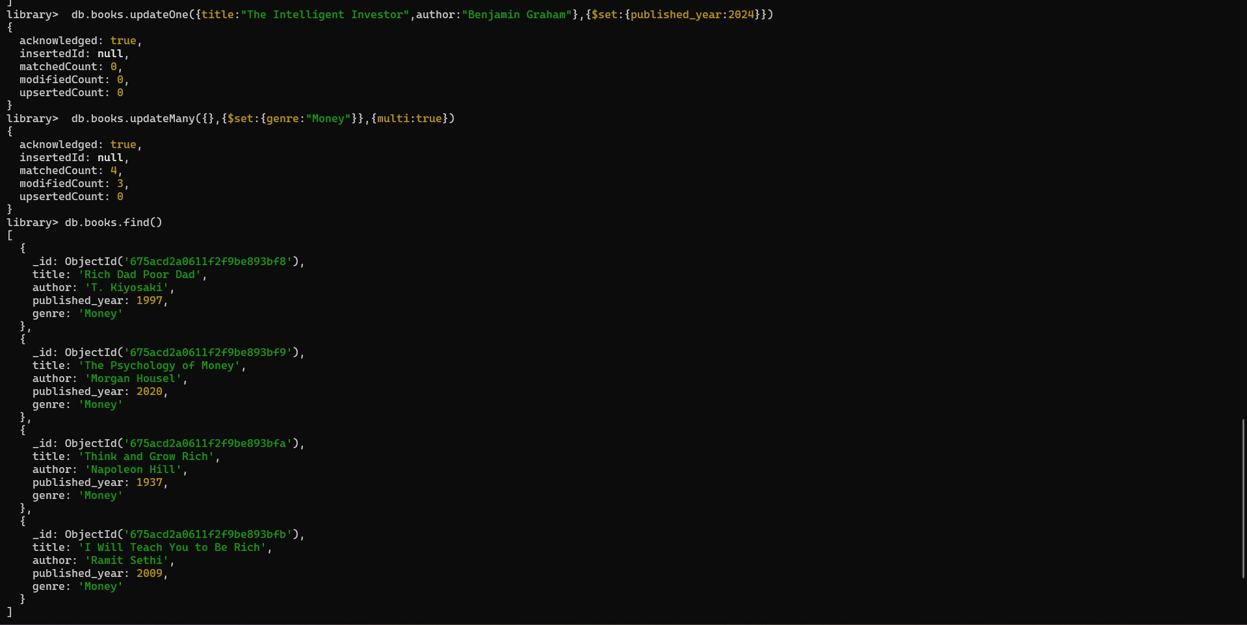

**Delete Operation:**

1. Remove the document with the title "Think and grow rich" from the "books" collection.
2. Delete all documents from the "books" collection where the published year is before 2000.

# Answer :

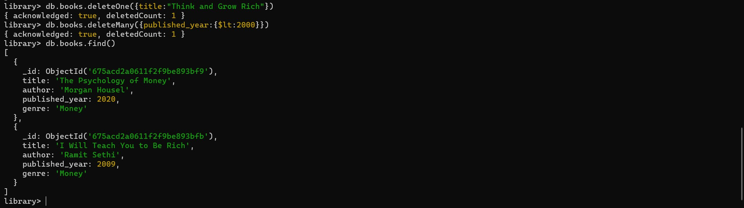

**Advanced Query:**

1. Find and display the top 3 recently published books from the "books" collection.
2. Retrieve documents from the "books" collection where the title contains the word "Genre" or "published_year:Lessthan 2000".

